CONVEYANCING

2016

SUMMARY

CAVEAT; Check out for accuracy as you read.

The Document is a mere summary. You can add, subtract.

The three landmark stages of a conveyancing transaction are:
- Making of the Contract
- Completion
- Registration

DUTIES OF THE ADVOCATE IN A CONVEYANCING TRANSACTION
Vendor‟s Advocate
Obtain information on: -
- Full names of the parties,
- full particulars of the property,
- the price,
- deposit is required,
- details of encumbrances
- whether the property is vacant,
- expected date of completion,
- prepare the sale agreement,
- obtain original title document from vendor,
- approve transfer/conveyance,
- procure execution of transfer/conveyance,
- receive and account for the proceeds of the sale to vendor.,
- obtain rates,
- rent clearances,
- consents where required,
- obtain discharge of charge/reconveyances.
Purchaser’s Advocate
Obtain information on:-
- finances, taxes
- legal costs and expenses of the conveyance,
- scrutinizing of title documents,
- investigation of title,
- approving sale agreement,
- preparation of transfer/conveyance
- engrossing the transfer/conveyance,
- attending to execution of the conveyance or transfer where necessary,
- stamping and lodging of documents where necessary,
- obtaining and paying the purchase price to the vendor‘s advocates.

FORMALITY OF WRITING IN CONVEYANCING
- The contract must be in writing executed by both parties and attested
- Section 3(3) of the of the Law Contract Act. No suit shall be brought upon a contract for the disposition of an interest in land unless-
- the contract is in writing.
- is signed by all the parties thereto; see Section 44(1) of the LRA every instrument effecting any disposition under the Act shall be executed by each of the parties consenting to it,
- (b) the signature of each party signing has been attested by a witness who is present when the contract was signed by such party:
- Does not apply to a contract made in the course of a public auction by an auctioneer
- writing serves three purposes: Evidentiary, Protective and Forensic (used in court of law)

Formality of Registration in Conveyancing
- Conveyancing is complete only once registration is effected.
- Registration is the keeping of records of land transactions in the Lands Register
- What is registered is usually the title or ownership to land and any instrument dealing with land or the disposal thereof.
The purpose of Registration
- enabling the Government to keep track of user
- easier collection of revenue
- simplifying dealings in land registration
- avail certainty and security of title or tenure
- Reduction of unnecessary litigation in matters relating to land
- Prevention of re-fragmentation of land
- Security of tenure; A registered proprietor acquires an indefeasible tile against the whole world ; owner has a right to indemnity from the govt.LRA 81-84
- Efficient administration and facilitation of the loan system
- Prevention of concealed dealings in land:
Effect of Registration
- Section 24 of the LRA the registration of a person as the proprietor of land shall vest in that person the absolute ownership of that land together with all rights and privileges belonging or appurtenant thereto
- section 25 of the LRA The rights of a proprietor, whether acquired on first registration or subsequently for valuable consideration or by an order of court, shall not be liable to be defeated except as provided under the Act
- subject to (a) to the leases, charges and other encumbrances and to the conditions and restrictions, if any, shown in the register; and
(b) Overriding interest (S. 28 LRA)
National Prov. Bank Limited –vs- Hastings (1964) Ch 9
Mbui –vs- Mbui (2005) I E. A 256
Marigi Vs Marigi 1996 LLR 463
Ogongovs.Ogongo CACA 29/2003
Esiroyo –vs- Esiroyo (1973) E.A.
- Section 26 LRA provides certificate of title to be held as conclusive evidence of proprietorship unless obtained by way of fraud or misrepresentation.
Rogan Kamper vs. Grosvenor 1977 KLR 123,
Clarke vs.Sondhi (1963) E.A.,
- Section 30 of the LRA, rights concerning land give no proprietary quality unless registered.

Reflections
- Cautions and caveats effect of,
- Overriding interests
- Abstract matrimonial property rights
- Adverse possession
Wambuguvs.Njuguna 1983 KLR 172
- Proprietary estoppel.
TengHuanvs.SweeChuan 1992 1 WLR 11

Where is registration done? Who does it? When is it deemed to have been done?
Page 26
INSIDE A LANDS‟ REGISTRY
- Filled Valuation Forms lodged with the Collector of Stamp Duty for purposes of valuation
- Particulars of property Form filled by conveyancer
- Valuation for Stamp Duty Requisition Form filled by the Collector
- sent to Chief Government Valuer for valuation. This is only applicable where the document is a transfer or Deed of Conveyance.
- Document stamped and duty paid at the Banks (KCB/NBK) then document lodged for registration
- Document presented in duplicate together with all relevant requisite documents e.g. original of the government ‘s valuation report, consent, clearance certificate, original title, e.t.c Fill out application for registration in quadruplicate. Pay registration fees. 500/=
- Upon Presentation of document and a day book number given entered into a register and date and time of presentation endorsed on the document for purposes of priority.
- taken to audit and Government Auditor ascertain stamp/duty, taxes-rent, rates, have been paid.
- Registration proper commences with the Registry- in charge of marking the documents for action in a register known as the ‘A‘ book
- verification of document by an officer in the registry: detection of any defects
- Inspection of the title by an officer to ensure title is clear and registration can proceed
- Entry of particulars of interest being acquired
- Document is then passed to relevant Registrar for execution and ultimate registration
- Registrar vets it and signs in approval or rejection.
- In epilogue:
- Document is photocopied (except RLA documents)
- Sealed with Land Registry‘s Seal (except GLA documents)
- Released to owner.If RTA,RDA,GLA or LTA the Registry keeps a photocopy
- RLA the Registry keeps the original and releases the counterparts
PROFESSIONALS
- Estate Agents
Their role is to identify a party to a conveyance i.e. the Purchaser or Vendor or the Financier, at a commission.
Recognized under the Estate Agents Act (Cap 533) Laws of Kenya.
Section 2(3) of the Estate Agents Act expressly exempts advocates from the provisions of the said Act.
Advocates by dint of the provisions of the Advocates Remuneration Order Articles 27 (Sales) and Article 30 (Mortgages) can also be agents even though they do not meet
For anyone to earn a commission as an Estate Agent one must be registered under the said Estate Agents Act.
- Omollo J. A. in Rajdip Housing Development Company Limited vs. J. W. Wambugu t/a Wambugu& Company Advocates C.A.C.A 4/1991.
It is otherwise a positive transgression of the law to practice as an estate agent when one is not registered
- Mapis Investment (K) Limited vs. Kenya Railways Corporation C.A.C.A 14 of 2005 and section 18 of cap 533
- Land valuer
- must be qualified under the Valuers Act- Cap 532.
- value the property especially if the purchase is financed by a bank.

- Planners (control of developments and subdivisions within local authorities)
Planners must be registered under the Physical Planners Registration Act no.3 of 1996.
- Architects
- qualified under the Architects and Quantity Surveyors Act (Cap 525).
- Create the architecture of the development
- Quantity Surveyors
They estimate the quantities and cost of the materials labour and time of the development.
- Land Surveyors
- must be qualified under the Survey Act (Cap 299).
- determine boundaries and mapping.
- useful when subdividing the property.
In what instance will you advise your client to engage the services of each of the above professionals?

INITIAL CLIENT INTERVIEW
PURPOSE
- gather all the relevant facts pertaining to the intended transaction
- afford crucial advise to the client on transactions generally and the particular transactions specifically
FIND OUT…
- Details of the parties - names, capacity, advise on co-ownership. SEE Barclays Bank PLC vs. Obrien (1994) 1AC 180, the House of Lords held as against the court of appeal, a wife who hasn‘t obtained independent legal advice any such mortgage will be void but only as against the wife.
Shah V Akiba Bank Limited (2005) 2 KLR.
- Details of the proposed conveyance: parcel number, fixtures, consideration. As an advocate you need to know the plot number, if the land only is being sold or there are fixtures.
- Authorization to disclose details and information about related transactions: Cf. Mortgage Express Ltd vs. Bowerman& Partners 1996 2 All E R 836
Held the advocate doesn‘t just protect the client but also 3rd parties for the sake of earning fees. You shouldn‘t encourage such fraud just to earn your fees.
- Details on pre contract enquiries ;
- Especially acting for seller
- you are bound to receive pre contract inquiries
- are searches that inquire on the physical structure of the property
- if it‘s the seller procure an evaluation report.
- Discussion on conflict of interest: when acting for buyer/ seller it is a general principle of professional conduct that an advocate must not act for two or more clients where there is a conflict of interest between those clients.
- The advocate must however not be involved in the negotiation of the sale price of the property.
- get the written consent of both parties for an advocate acting for both the seller and the buyer
- Acting for lender and borrower is generally permitted.
- nature of the advice you offer the client must be independent O’Brien.
- Discussions on fees.-
- Information on fees to be charged must be confirmed in writing at the start of the conveyancing transactions
- agree on the advocates fees for the whole transaction
- inform the client the right to increase the advocate's charges in case
- Discussions on financing and financial implications of the transaction
deposits, stamp duty, undertakings
- Details on the title documents: Obtain copies of the title document

What is the principle of ―Independent Legal Advise ―all about?

INVESTIGATION OF TITLE (AND PROPERTY)
Whether the ‘owner’ is the legitimate owner.
Whether what is being acquired is a good marketable title.

What are patent defects? And latent defects? Can you figure out some examples of either?]
Reasons for investigation of title
- Buyer beware : A Seller is under no obligation to disclose patent defects but he is under an obligation to disclose such latent defects as he may be aware of.
- a bona fide Purchaser for value without notice acquires a good title to property unaffected by matters of which he had no notice
- A conveyancer must exercise due diligence ; Failure to do so may result in a successful claim for negligence.
Investigation of title is part of defensive conveyancing. Vendor- deducing of title, disclosure of latent defects:
- This is the responsibility of the vendor.
- Vendor is expected to deliver on the promise that he has good title to the property
- it is expected that the devolution of interest in a property is best known to the vendor.
- Vendor deduces the title by submitting an abstract of title;is a brief history of the property showing how the interest in the property moved from one person to another, the encumbrances and any other thing that may affect the property.also called an epitome of title
- LSK Conditions of Sale- cond. 9 requires the abstract to be presented by the vendor within 14 days of the date of the agreement
- Immediately after receiving the abstract/epitome of title it is the duty of the purchaser to conduct an investigation of the title.
The purchaser is expected to go to the following places:
- Land Registry
- Company Registry-
- Probate Registry
- Local Authority
- Survey Department to establish boundaries
- Physical Inspection of the property
- Court records
MEDIUMS OF INVESTIGATING THE TITLE OR PROPERTY
- Searches
- Like registration, searches also shield against fraud.
- carried out usually by the Purchaser ‘s or Chargee ‘s or Leassee‘s Advocate in the government departments
- In conducting a search one ought to get details of ownership, of special conditions, of the tenure, of the rental, of the user, of encumbrances and quasi-encumbrances (i.e. caveats). purposeful inspection of title records or register at the relevant (Lands) Registry.
- Include searches at the Companies Registry to confirm existence of the Vendor or solvency of such Vendor
- search at the Local Authority Registry to ascertain any planning hindrances
- notices search at the Survey Department to reconfirm or identify boundaries.

- Pre Contract Inquiries
- relate to matters touching on the physical condition of the property as well as other matters not covered by searches.
- Are also medium of investigating the title or property
- relate more to the physical condition of and location of the subject property
- Purchaser will conduct a personal inspection of the property
- The inspection is conducted to help ascertain ; the value of the property, detect physical and patent defects, ascertain those in occupation.
- to check on thefixtures and fittings, if any
- include development prospects and planning permission matters of the property and adjoining property, access to the property, boundaries of the property, water supply, physical defects.
NB ; When acting for the Vendor it is important not to presume any answers to pre contract inquiries but to consult with the client.Any misleading answers relied upon by the other party might lead to a cause of negligence.Gran Gelato Limited –vs- Richcliff (Group) Ltd [1992] 1 All ER 865.
- Requisitions
- are in the form of forthright questions arising after a perusal and deduction of the title document.
- Requisitions relate to matters which arise not on the basis of the search or simple physical inspection of property but through the inspection of the title document or abstract availed.
- Relate to ;
- tenure or the property
- execution of the title document,
- identity of and description of the property
- underpaid stamp duty
- identity of the encumbrances if detected on the face of the title.
The LSK Conditions of Sale (1989) at Condition 10 provide for the requisitions or objections to be made after the contract has been executed and in any event not later than fourteen (14) days after delivery of the abstract, title deed or a copy thereof
Vendor is under an obligation to fully and correctly answer the requisitions.

SIGNIFICANCE OF SEARCHES
- Helps a conveyancer discover restrictive entries such as caveats, caution, prohibitions or restrictions on tide
- Discover any other encumbrances
- Discover whether the proposed vendor is the registered proprietor.
SIGNIFICANCE OF SEARCHES
- check the state and condition of the property.
- check who is in Actual Occupation of the Property
- check boundaries
- check on rights and easements affecting or benefiting the properly.
- check fixtures and fittings contracted to be sold are in the subject property just prior to the exchange

EXECUTION & ATTESTATION
EXECUTION is the signing of documents the purpose of authenticating and acknowledging the same.
- the mere typing of a name is not a signature. Lord Denning in Goodman Vs J. Eban 1954 1QB 550
- Section 3(6) of the Law of Contract Act (Cap 23) Laws of Kenya). Section 44 of the LRA provide for execution of documents.
- Natural persons can sign by themselves or by their duly constituted Attorney(s).
- Companies and other juristic persons will execute the document as per the provisions of their respective constitutions.
- Actual conveyancing instruments must be signed by the proprietor or his duly constituted Attorney,
- A Sale Agreement may be signed by he who has ―apparent or ostensible authority and not necessarily actual authority.

ATTESTATION is the proper witnessing of a signature or execution .
- A Vendor must not witness the Purchaser‘s signature and vice versa.
LamchandFulchand Shah –vs. - I & M Bank Limited C. A. C.Appl. No. 165 of 2000
- where there is a question of proper or improper attestation then the Advocate who purportedly witnessed the execution must be made a party to the suit.
Coast Brick –vs- PremchandRaichand 1966 E. A. and Eccon Construction & Engineers –vs- Giro Commercial Bank [2003] 2. EA LR 426
- A document executed by a company does not necessarily require to be attested.

VERIFICATION
section 45 of the Land Registration Act.
- A person executing an instrument is required to appear before the Registrar, public officer or other person as is prescribed.
- Registrar, public officer or other person shall then identify the person and ascertain whether the person freely and voluntarily executed the instrument, and shall complete thereon a certificate to that effect
POWER OF ATTORNEYS
- authority in writing by donor that enables another – donee to act for him.
- Attorney is a person who is appointed by another and has authority to act on behalf of another
- Authority could be general or special (specific).
- authorizes the donee to do some lawful act on behalf of the donor
- The authority is contained in a Letter of Attorney
- could be irrevocable or revocable
- Donee cannot act ultra vires
- RLA prescribes a mandatory form to be used in donating the authority; must be executed by donor and the execution verified.
- The act must be done in the name of the donor.
- Donor must have capacity ; where a person purports that he has a power of attorney donated to him by a person of unsound mind, as was the case in Grace WanjiruMunyinyi& another v GedionWaweru& 5 others,7 the power is null in law.
- Must be stamped and registered in the Register of Powers of Attorney
- Stamp duty is payable by the donor/executor

POA CAN BE REVOKED BY
- By the donor executing a revocation
- By performance of the act it was created to perform Functus Officio.
- Expiry of time
- Operation of the law e.g. when the principal becomes a bankrupt, his power of attorney in relation to property or rights of which he was divested by the bankruptcy, is revoked by operation of law.
Dealings in land by an agent
- Section 48 LRA Unless PoA is granted, dealings with an interest in land shall not be accepted for registration where it is signed by an agent.
- The original of such power of attorney must be filed.
A copy of PoA can only be filed with registrar’s consent. The copy must be certified.
Exception to S.48(1)
- section 48(3) of the LRA, guardian of a person under a legal incapacity or a person appointed under a written law can represent a person under LRA W/O PoA.
- A person who applies under Cap 248 – Mental Treatment Actto manage the property of an insane person need not have a power of attorney.

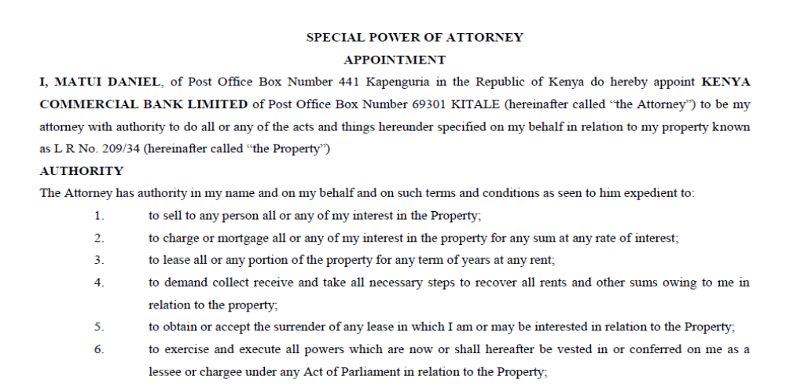
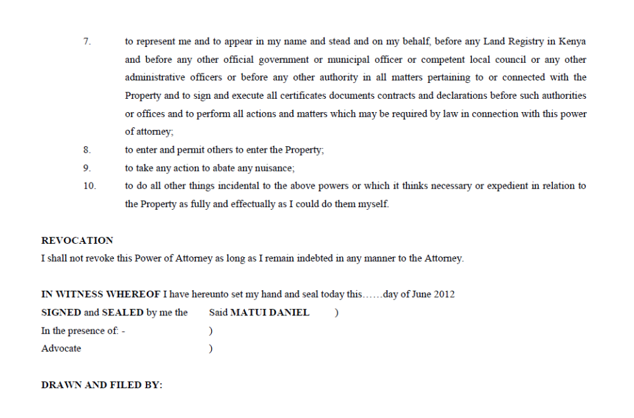
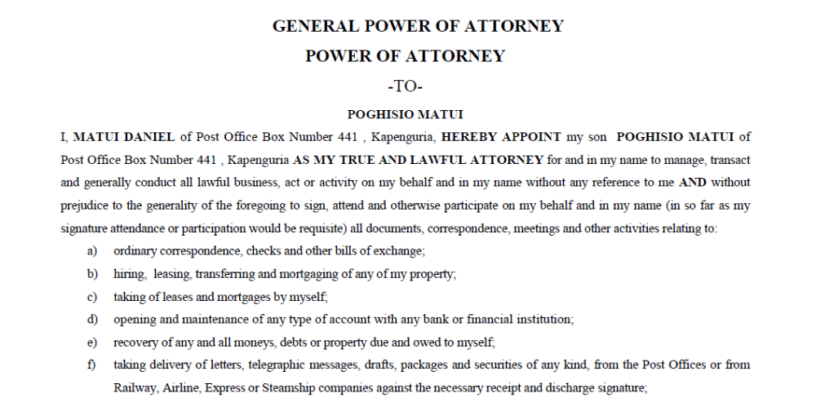
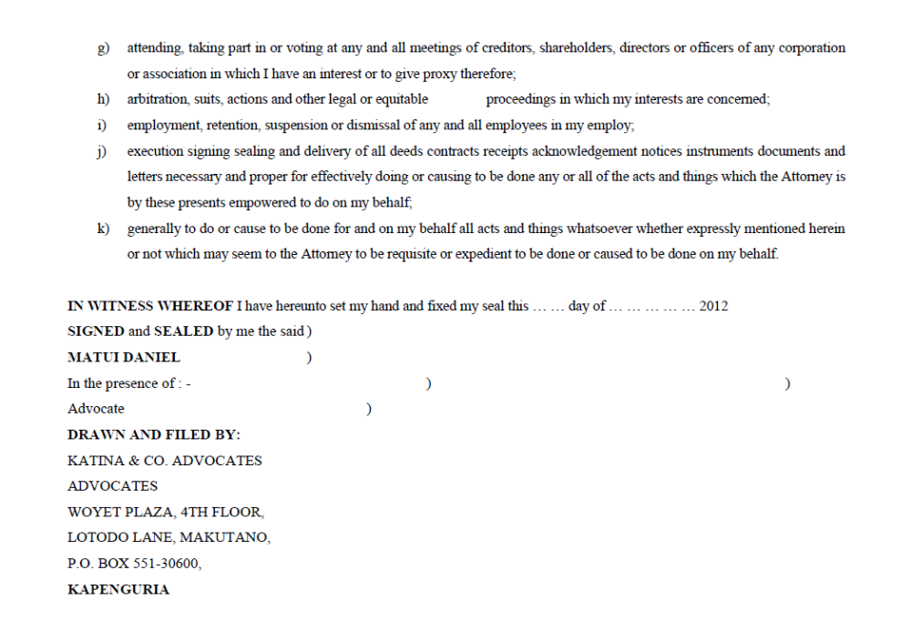
STAMP DUTY
- stamp duty is basically revenue raised by the Government by requiring stamps sold by the Government to be affixed to designated documents
- Section 5 The Stamp Duty Act (Cap 480) demands that every instrument relating to property in Kenya be stamped.
- Section 6.The duty is to be paid within 30 days of execution of the document or of its receipt if it is executed outside Kenya
- Section 113 Failure to pay duty is equivalent to evasion of tax and is a criminal offence.
- Section 46 of the LRA no document is acceptable for registration if the stamp duty required to be paid has not been duly paid and documents properly stamped.
- Duty on conveyancing instrument is paid on the ad valorem value(proportionate to the value)at the statutory rate.
- Transfers – 4% for properties situate within cities municipalities
2% of the value for properties outside municipalities/cities;
- charges and Mortgages – 0.1% of the amount secured;
- Discharges/Reconveyances -0.05% of the amount secured and
- Leases 1% of the annual rent for a Lease of less than 3 years and
2% of the averaged rent for a Lease of 3 years or more.
- Long term Leases or subleases are deemed to be Transfers and fetch duty as if they were Transfers.
NB
- The minister may grant Relief and or exemption to charitable organizations as well as religious organizations.
- Certain institutions are also duty-exempt eg educational institutions, government departments e.g. Central Bank of Kenya and the Export Processing Zone Companies.

when do you date the conveyancing instrument?

Process:
- Applicant presents document for assessment by collector. Fills Form SD1
- Assessor confirms if duty is payable, counterchecks info on the form and document, ascertains amount and endorses both Form and document
- Applicant pays amount in designated bank
- Returns document with proof of payment to Collector of Stamp duty
- Collector of Stamp Duty reconciles records and stamps document by franking
- Audited by Government accountant and dispatched

RATES & RENT CLEARANCE CERTIFICATES
- RATESCLEARANCE CERTIFICATES
- Rates are levies payable to the Government through the local authorities under the Rating Act.
- Upon full payment of rates due on any parcel of land, the local authority‘s Clerk issues the owner of the parcel with a Rates Clearance Certificate.
- RCC is prima facie evidence that the rates due and any interest accrued thereon have been fully paid.
- Sections 38 of LRA require that prior to the Registrar accepting any document intended to transfer or vest any interest in land for registration, there must be also produced a valid RCC.
- levied on all parcels of land, freehold or leaseholds.
- Certify that; the following have been paid
- Land rates
- Interest charges on rates and
- Unpaid water bills.

- LAND RENT CLEARANCE CERTIFICATES
- Levied only on leasehold parcels where the annual rent has been reserved at the time of the Grant being issued.
- No LRCC is necessary where land is freehold.
- Section 39 of the LRA before any transaction on a leasehold property is registered, the parties must produce to the Land Registrar a valid Rent Clearance Certificate.
- Clearance Certificate is a document which certifies that all land rent due has been paid.
- It is always the duty of the registered proprietor to pay and obtain the Rates and or Rent Clearance Certificate.
what is a peppercorn?
What is the process of obtaining RCCs
Any challenges?

CONSENTS.
- Different transactions however require different consents
- Condition 16 of the LSK provides that for purposes of completion, all necessary consent must be obtained by the vendor/lessor (he who is parting with the interest).
- Consent from the County Land Management Board
- S.39(2) of the LRA no transaction to be registered unless CLMB consent has been acquired.
- includes paying all outstanding land rent.
- applicable only to leasehold properties and not freeholds.
- Land Control Board Consent
- Section 2 of the Land Control Act applies to all land designated as ―agricultural land.
- Section 6 of the Land Control Act. Outlines the particular transactions.
- The consent is granted by the local Land Control Board on application by both parties to the transaction.
- The application is made in a prescribed form
- consent also issued in a prescribed form.
- President may exempt Agricultural land from LCB consent or if govt is party to the tr.
- S.6(1)within six (6) months from the date of the transaction otherwise the transaction is null and void

- Nelson Githinji et al vs. MuneneIrangi COA categorically stated any transaction, sale, transfer or other disposition or dealing in agricultural land situate in a land control area without a Land Board Consent is void. Having not been obtained within the required time i.e. 6 months, the whole disposition was void as against s.6 LCA
- Mucheru v Mucheru [2002] 2 EA 456
The CA held that if LCB consent is not obtained the transaction becomes void even if the duty to obtain the consent was not exercised.
- Jacob Minjire –vs- Agriculture Finance Corporation
Facts :
- AFC exercised chargee’s power of sale.
- Sold to appellant.
- Owner redeemed.
- Consent had not been obtained in respect of the sale.
Held:
- LCB Consent is statutory without which, a contract is vitiated.
- The Act gives an innocent party to a nullified transaction special cause of action.
- Consent has to be applied for within three months from the date of agreement.
- Neither special nor general damages are recoverable in respect of a void transaction.
- The Consent of the Kenya Railways
- For any land adjacent to or adjoining the Railway land,
- the consent of the Railways Corporation is required prior to any dealing in that land.
- The Consent of the Kenya Airports Authority
- The Consent of the Landlord Lessor’s Consent]
- The Consent of Trustees of National Parks

DISPOSITION IN LAND
Is a transfer of an interest in land.

STAGES IN DISPOSITION
- First- contract for sale : S3 RLA do not consider a contract for sale of land as transferring interest in land.
The essence of K for Sale
- deals fully with the matters that must be dealt with between the date of the contract and completion;crystallizes the position of the parties
- binds the parties to the sale, prevents last minute withdrawal.
- It makes the transaction enforceable-S. 3(3) of the Law of Contract Act.;
- Parties may use it to confer special advantage on themselves
- may be used to transfer the legal interest on chattels so as to reduce the duty payable at the completion stage.
- provides for the resolution of any disputes that may arise between the date of the contract and completion;
- provides remedies for breach;
- gives the purchaser time to investigate the title
- The equitable doctrine of conversion is applicable to these kinds of contracts

TERMS OF CONTRACT FOR SALE OF LAND
- It is open for the parties to make a contract as they deem fit.
- In practice certain standard forms of conditions have been settled on
- LSK Conditions 1989 outlines various terms and conditions for the sale of property
VENDOR/SELLER | BUYER
- To disclose latent defects  - To produce upon request title documents  - Answerrelevant questions from the buyer  - Execute a conveyance on payment of the purchase price  - Take care of property between date of contract of sale and delivery Dharmshi V Abdul Reikhman (1950) 204 KLR  - To give possession of the property when required.  - Pay public charges and rent  - S 46-48 of Sectional Properties Actfor sale of sectional properties the terms must be certain.Michira vs. Gesima Paper Mills Ltd (2004) EA 168 The entire agreement was held to be void for uncertainty | - Disclose to the seller info which increases the value of the property.  - Pay purchase price on completion  - If sold free of encumbrances retain part of purchase price to cover encumbrances  - When property has passed to him bear losses on the property not caused by seller  - Where property has passed to him, pay all public charges, rent etc.

- Conveyance; S 54 ITPA where the transfer of an interest in land takes place.

INGREDIENTS OF A VALID CONTRACT
There must be a final, complete, written contract on at least the essential terms:
- Offer
- Acceptance
- Consideration
- Capacity
- Intention to create a legal relationship
ENFORCEABLE CONTRACT
s.3 LCA
- Written
- Signed
- Attested to.
How can enforceability be defeated by the application of the equitable doctrine of part performance?

JUDICIAL INTERPRETATION OF S3 (3)

Prior to 2003 :
Wagiciengo vs. Gerrard (1982) CAN 336.It was held that 2 unsigned documents (one contained terms of the agreement, the other a schedule of payments received) in the defendant‘s handwriting, satisfied the requirement of S3(3) of LCA
Post 2003
Kenya Institute of Management vs. Kenya Reinsurance Corporation 2008 eKLR
- D advertised its property (South C Sports Club) for sale..
- P made offer
- Entered negotiations and agreed on purchase price.
- P sought financing.
- D sought to withdraw.
Held:
- no agreement within the meaning of S3(3) existed
- Granted the injunction on the basis of high handedness of the defendant
Mumias Sugar Co. Ltd vs. Freight Forwarders (K) Ltd Nairobi 2005 eKLR-
Held ;
- S3 (3) conditions were not satisfied.
- the contract void but merely make it unenforceable.

SALE AGREEMENT BRIEF
Will always be drawn by Vendor ‘s Advocate; see Salim –vs- Okongo, 1976 KLR 42, LSK Condition 24.
- Parties have freedom to contract.
- vendor becomes the trustee for the purchaser
- There is no statutory requirement for the format of a sale agreement.
- The agreement must comply with LCA and other statutory requirements
- Must comply with Law of Contract principles : offer, acceptance, consideration and intention
- Must comply with form under S.3(3) and Sections 38 through 42 of the Land Act 2012.: written, signed and attested to and the terms of the agreement ought to be in one document.
- ex turpicausa non orituractio : agreement must not be tainted with any illegality
- Must not be unconscionable.
- Must be certain or its voidMuchira v Gesima Power Mills Ltd (2004) 2 EA 168.
- ordinary Sale Agreement will contain five parts namely:
- the parties: parties to k properly identified, their addresses.
- particulars of sale,
- description of the subject property ; physical and legal
- Encumbrances, if any ; who will service them.
- fixtures and fittings :
- whether a structure or an item has become a part and parcel of the land itself depends on the degree of annexation as well as the object and purpose of annexation and the test is objective.
- latin maxim of quic quid plantatur solo solocedit does not apply.
- Their provision may affect the stamp duty payable.
- consideration (purchase price).
- special conditions.
- terms which are peculiar or specific to and relevant to the contract in question.
- involve issues of vacant possession, deposit, fixtures and fittings, remedies in the event of default..variation of general conditions.
- conditions which apply sui generis to each agreement.
- general conditions
- terms which in the absence of any specific terms apply generally to the open contract.
- Apply to fill up gaps in contract. Cover a variety of matters.
- Their source ; Common law, equity, conveyancing practice.
- Section 55 of the ITPA.
- LSK Conditions of Sale.
Matters regulated by general conditions
- Regulating right to rescind
- preparation and content of transfer
- possession and grant
- deposit and forfeiture ; LSK Condition 3 ; Universal Corporation –vs- Five Ways Properties
1997 1 All ER 254
- notice to complete ; LSK Condition 28Must be explicit and unambiguous.
- completion ; LSK Conditions 2 & 4
Completion time
Duty of Vendor: to deliver
(i) Vacant possession; i.e.
- Free from physical impediment
- Free from any form of occupation
(ii) Completion documents.

Duty of Purchaser:
- to inspect completion documents,
- authorize release of deposit and deliver balance of purchase price.
- execution.

CERTAINTY
Muchira v Gesima Power Mills Ltd (2004) 2 EA 168
- An agreement must be certain.
- COA held that any agreement that contains uncertain clauses is void and specific performance or reliance on it for any remedy will not be allowed.
- Facts
- vendor sold land to the purchaser for 10 million.
- Parties drew the agreement
- Execution witnessed by tan advocate
- 10% deposit was to be paid on execution,
- 20% later
- balance within 90 days or when the title was produced
- Possession was to be granted on completion or when 20% was paid
- damage on default was 40% of 10 million.
- The purchaser alleged default and sued for 4 million.
Held : agreement was not enforceable even though it had met all the statutory requirements.
There was no consensus ad idem as to when the balance and possession would be given.

MODEL SALE AGREEMENTS
Details
- Parties ;who’s contracting?
- Definitions and Interpretations ; Vendor means….purchaser means?
- Incorporation of LSK Conditions for Sale ;
- their incorporation is not mandatory****You can exclude/allow some****.specifically state which LSK conditions to incorporate eg
The Law Society Conditions of Sale (2015 Edition) so far as they are not varied by or inconsistent with the conditions herein are deemed to be incorporated in this Agreement.
- Agreement for Sale and interest sold ;
- vendor agrees to sell and the purchaser agrees to purchase the Property at the purchase price.
- The interest sold is
- Special conditions
- Any Variation of general conditions?
- Capacity
- Legal competence for a person to sell; are you selling as attorney, administrator, agent, beneficial owner.
- Purchase price and Deposit
- The Purchaser shall upon execution of this agreement pay a deposit in the sum of Kenya Shillings (Ksh )…… to the Vendor’s Advocates to hold as stakeholder pending completion.
- The Balance of the purchase price in the sum of Kenya Shillings (Ksh ) shall be paid to the Vendor’s Advocates on the completion date.
- Completion
- The Completion Date shall be on or before the expiry of Ninety (90) days next following the date this agreement. (Lsk Conditions 2015)
- Completion documents; In exchange for the Purchase Price or a suitable undertaking to pay the balance of the Purchase price, the Vendor’s Advocates shall deliver to the Purchaser’s/ Financier’s Advocates the following;
- The original Title document of the said property;
- Valid Land Rent Clearance Certificate (if applicable);
- Valid Rates Clearance Certificate (if applicable);
- Consent to transfer from the relevant authority (if applicable);
- Duly executed Discharge of Charge (in triplicate) (if applicable);
- Duly executed undated Transfer (in triplicate) in favor of the purchaser and/or his nominee;
- Copies of the Identity Cards / Passports and PIN Certificates of the Vendor and/or its directors (if applicable) duly certified;
- Three passport size coloured photographs of the Vendor;
- Any other document necessary to effect registration of the transfer in favor of the purchaser, including copies of the Transfer by way of sale.
- Matters Affecting The Property
- The Property is sold subject to and with the benefit of all easements quasi easements rights exceptions and other similar matters which are apparent on inspection.
- The property is otherwise sold in the condition it is at present and the Vendor shall not be required to repair the same or make any further improvements.
- Prior to the completion date the Vendor shall point out the boundary and beacons on the property.
- Possession
- The property shall be sold with vacant possession.
- Breach Of Agreement By Either Party.
- If the Purchaser fails to comply with any provisions of this Agreement, the Vendor shall be entitled to serve him with a Notice in writing requiring him to remedy the same within Twenty One (21) days from the date of service of the notice.
- If the Purchaser fails to remedy the breach before the expiry of the said Notice then the Vendor shall be entitled at the Vendor’s absolute discretion either-
- To extend the time for completion; or
- To rescind this Agreement by notice
- To retain Ten Percentum (10%) of the Purchase Price as liquidated damages.
- If the vendor fails to comply with any provisions of this Agreement, the Purchaser shall be entitled to serve him with a Notice in writing requiring him to remedy the same within Twenty One (21) days from the date of service of the notice.
- If the Purchaser fails to remedy the breach before the expiry of the said Notice then the Vendor shall be entitled at the Vendor’s absolute discretion either-
- To extend the time for completion; or
- To rescind this Agreement by
- To immediately demand and require a full refund of the deposit.

- Costs
- Each party shall pay the legal charges of their own Advocates of and incidental to the preparation and completion of this Agreement and Transfer.
- Stamp Duty and other related costs
- Non merger Clause.
- The clauses should be read as distinct and separate such that in the event that one is null and void, it should be severed and will not affect the others.
- Disclaimer
- LSK Condition 14 clause 5 caveat emptor doctrine
- vendor shall not be called upon to point out irregularities in the property
- General obligations
- saving clauses,
- how and when payment is to be made,
- whether the amount would be net or gross
- whether the agreement, if it is to be varied, how?
- Intention to be bound
- It is the parties’ affirmation to the contract especially in relation to the law of contract act.
- Miscellaneous clauses and provisions
- Delay in exercising a right or power by a party does not mean a waiver of that right.
- remedies are cumulate and not exclusive of any remedies provided in law
- An invalid term does not invalidate all the agreement
- Execution
- This is the affixation of one‘s mark on the document. It may be by way of signature, thumb print.
- parties have to authenticate the document.
- state the capacity in which the parties are executing the document.

SALE AND PURCHASE OF LAND
Steps Commonly To Be Taken By Seller’s Advocate
- Take instructions from Seller ;
- including details of proposed purchase price
- Discuss fees, disbursements, taxation matters
- Confirm instructions
- Draft initial letters To agents, to client, to Buyers Advocate.
- Obtain Title Deeds from Seller and other documents necessary for purposes of sale
- is consent required? From who?
- outstanding outgoings?
- Draft and reconfirm with Seller answers to pre contract inquiries
- Draft the Contract
- and dispatch to Buyer‘s Lawyer.
- Send a copy to Seller for approval.
- Also include ; abstract of the Title, seller’s reply to pre-contract inquiries, copies of consents
- Engross the Contract (Sale Agreement) on receipt from Buyer.
- Return Contract to Buyer for execution or signature
- Receipt and deposit in the client account any deposit payable
- If deposit cheque has been honoured, ask seller to execute the contract.
- Return counterpart copy of the Contract to Buyer‘s Advocate.
- Advise Seller that he has a continuing duty of care towards the property
- Reply to any requisitions on title
- Peruse and approve the Draft Conveyance and return the approved/revised Conveyance.
- Prepare for the redemption of any Mortgage(s).
- Prepare a Completion Statement. Purchase price less deposit paid add apportionments (and interest?).
- Arrange for execution of the Conveyance.
- Arrange for and host completion meeting.
- Report completion to Seller and authorize release of keys to Buyer.
- Account to client for proceeds of sale.

STEPS COMMONLY TO BE TAKEN BY BUYER‟S ADVOCATE
- Take instructions from Buyer.
- Consider conflict of interest
- Discuss and agree on fees
- Receive and deposit the Deposit in the client account.
- Lias with buyer to have survey and/or physical inspection of property
- Advise Buyer on taxation matters
- Consider Surveyors or Valuer‘s Report.
- Deal with planning matters.
- Make pre-contract searches and enquiries.
- Consider the draft Contract and raise pre contract enquires of the Seller.
- Investigate Title and raise requisitions.
- Consider Seller‘s replies to pre contract enquiries and requisition.
- Amend draft Contract as necessary and return to Seller.
- receive engrossment of Contract.
- Arrange for execution of Contract.
- Return engrossed and executed Contract together with deposit cheque to the Seller‘s Advocate.
- Receive counterpart Contract signed by Seller.
- Draft Conveyance and
- Send conveyance for approval and upon its return engross same.
- Make pre completion searches.
- Receive all monies (disbursements, fees, balance of purchase price and apportionments).
- Attend completion and report to client.
- Stamp Conveyance Get Conveyance endorsed with assessed value
- Give notice to tenants.
- lodge Conveyance for Registration
- Account to client and release title documents to client.
- Dispose of any other documents as instructed.

NB:
Openda v Khan
Sale agreement creates no interest over the property

Salim v Okongo [1976] KLR 42
The transfer is always drawn by the plaintiff‘s advocate save in very exceptional circumstances e.g. in mortgages and subleases.

PROFESSIONAL UNDERTAKINGS
- What is it? It’s an unequivocal declaration of intention by an advocate in the course of his practice. It’s addressed to someone who reasonably places reliance on it.
- Why; Given by lawyers to smoothen and hasten the process of transactions.
- When is it given?
- Vendor‘s Advocates ; undertaking not to release the purchase price to Vendor pending actual registration of the Transfer.
- Mortgagee‘s Advocate; undertaking to advance the loan upon registration of the Charge plus/or transfer simultaneously.
- Mortgagor‘s Advocate undertaking to pay the redemption amounts upon registration of the discharge.
- ???
PUs involve arrangements for settlement such as
- Payment of purchase monies
- Loan funds
- Discharge of obligations
- Accounting to the other party for documents in return

PRINCIPLES OF PUs
- unequivocal declaration of intention by advocate in the course of his practice, addressed to someone who reasonably places reliance on it.
- Failure to honor a PU is a prima facie evidence of professional misconduct.
- The LSK cannot compel the advocate to honor but the LSK can take disciplinary measures.
- The LSK obligates such advocates to honor PUs so long as their names are in the Roll, it matters not whether they have no practicing cert.
- LSK cannot order the release of an Advocate from the terms of an undertaking. This is a matter for the court.
- A PU will normally be required to be honoured only as between the giver and the recipient.
- Advocate cannot assign the burden of an undertaking without the express approval of the recipient. ROA OtienoVs AGN Kamau& Co 134/03
- Court may enforce a PU on an application by the recipient‘s client. NaphtallyRadier vs. David Njogu t/a D. Njogu& Co. Advocates HCCC No. 582 of 2003 (Nrb), Kenya Commercial Bank Limited vs. Mohammed Muigai Advocates HCCC No. 757 of 2003
- An ambiguous PU is generally construed in favour of the recipient. (Contra preferentum rule)
- An undertaking does not have to constitute a legal contract to be enforceable in court.
Peter Ng’ang’aMuiruri vs. Credit Bank & Charles Nyachae t/a Nyachae& Co. Advocates (Civil Appeal No. 263 of 1998-Court of Appeal Nairobi).
- An undertaking is still binding even if it is to do something outside the Advocate’s control.
(Before giving a PU consider whether it is implementable)
- An Advocate is responsible for honouring an undertaking given by a member of the Advocate‟s staff,
- Where an Advocate in partnership gives an undertaking as an Advocate in the course of practice, all partners are responsible for its performance.
- An Advocate cannot avoid liability on an undertaking by pleading that to honour it would be a breach of duty owed to the client.
- An Advocate who gives an undertaking which is expressed to be dependent upon the happening of a future event must notify the recipient immediately if it becomes clear that the event will not occur.
- The court, by virtue of its inherent jurisdiction over its own officers, has power of enforcement in respect of undertakings.
- An undertaking should not be given by an Advocate as an inducement to a client to secure that client‟s business
- Seeking of PU which ought not to be given may constitute Professional misconduct.

BRIDGING OF COMPETING INTERESTS
- An undertaking by an advocate is subject to supervision by the Court.
- breach of PU amounts to professional misconduct which is enforceable in Court for breach of contract
- PUs are based on mutual trust.
- In common law there’s a concept of implied undertakings. This concept applies e.g. to return documents held should registration fail.
- PUs ought to be given to professionals not to laymen. Contrast with KCB Limited vs. Adala 1983 KLR 467 Undertakings can be given even to lay persons.
- ought to be in writing although no law bars oral undertakings.
- The giver and recipient don‘t have to be in an advocate/client relationship. See Bridge up Containers Services vs. GichanaBw’omwando t/a GichanaBw’omwando& Co. Advocates, Misc. Civ. App. 386 of 2006).
- LSK Digest ‘undertaking shall be is clear and once accepted by an Advocate shall bind him or his firm to the undertaking and any breach thereof shall constitute professional misconduct.
- An advocate as an officer of the Court is obliged to honour his professional undertaking Naphtali Radier vs. D Njogu& Co. Advs.
- Is PU a Contract? No! It is a solemn thing, in enforcing it the Court is not guided by considerations of contract but the Court aims at securing the honesty of its officers.
See Peter Ng’ang’aMuiruri vs. Credit Bank & Charles Nyachae t/a Nyachae& Co. Advocates (Civil Appeal No. 263 of 1998-Court of Appeal Nairobi).
- must be clear, unambiguous and certain and without conditions precedents.

- see Kenya Re V MugukuMuriu t/a MugukuMuriu& Co. Advocates (Civil Appeal No. 48 of 1994)
- See Kimaru J’s ruling in Pyrethrum Processing Co. Ltd vs. Rogers Shako Adv. HCC 148 of 2004- an undertaking is a form of trusteeship
- See Onyancha J‘s ruling in David Muema vs. Victor Mulee (eKLR 2007)- undertakings should be looked at from an ethical point of view
- See DK Thou & Co. Advs vs. NjagiWaweru& Co. Adv. HCC No. 209 of 2008- Justice Njagi refused the Advocates‘ arguments that he was entitled to a lien over the funds.
- Remedies of recipient of PU for breach by the undertaking party

- Co-operation with the undertaking party e.g. extending time
- Demanding compliance in writing
- Seeking enforceability through Court action O52 CPR through an Originating Summons
- Reporting the matter to LSK for disciplinary action
- can be enforced even if one is not the recipient-KCB V Mohammed MuigaiAdv (HCC757 of 2003)

COMPLETION
Condition.2 LSK Conditions of sale 2015
- “Completion” means the act of completing the sale of the Property for consideration pursuant to the Agreement and includes:
- Process of transferring (by registration or otherwise) the interest in the Property to the Purchaser ;
- The granting of legal possession of the Property to the Purchaser;
- Settlement of utilities bills and transfer of utilities accounts; and
- Apportionment of outgoings between the Vendor and the Purchaser.
- The Vendor completes by giving the Purchaser all the registrable documents plus possession
- Purchaser completes by giving the Vendor the balance of the purchase price.
- It is the final settlement of business.
- Title will only vest upon registration

Consider the below
- The date of completion
- The venue of completion
- The completion documents
- The obligations of either parties at completion.
- Completion notice

- Completion Date” has the meaning given in condition 8.1; ie
- means the date specified in the Agreement,
- Where it is not stated in the agreement; the ninetieth day (90th day) after the date of the Agreement.
- the completion date may be mutually extended.
- Where the parties provide that the time is of the essence then the completion date must be strictly adhered to.
- time is only regarded as of the essence if the parties make it so expressly as a term in the contract.
- The courts may by necessary implication make time of the essence.
Barclay –vs- Messenger [1989] 3 All E.R. 492 (essence can be implied)
- “if the Purchaser should fail to pay the balance of the purchase price on a given date, the agreement would become null and void.
- Held : Sir George Jesse M……time was of the essence.

NjamunyuVsNyaga 1983 KLR 282(essence can be implied)
- In case of unreasonable delays despite requests to complete, the provision as to time being of the essence can actually be implied.

- Failure to complete in such a case will be deemed a fundamental breach of contract both at law and in equity.
- The aggrieved party is free to pursue his remedies for breach of contract including specific performance.
- He may elect to rescind the contract .
- When time is not of the essence, a breach may not entitle the aggrieved party to decline to proceed with the contract.
- Where the Notice is not heeded then one is entitled to rescind as the Notice itself now imposes the ―time is of the essence‖ condition.
Time will not be of the essence unless
SagooVsDourado 1983 KLR 365…..court of appeal
- Parties expressly stipulate
- Nature of the subject matter show that time should be of the essence
- A party subjected to unreasonable delay gives notice to the other making

- "Completion Documents" means
- the deeds and other documents that are necessary for the transfer of good title and as may be defined in the Agreement,
- in the absence of any definition in the Agreement , means the documents set out in Condition 8.4.1; On the completion date, the Vendor shall give the Purchaser the following Completion Documents:
- Original Certificate of Title for the Property
- Duly executed Transfer, in triplicate, of the Property in favour of the Purchaser;
- Original valid Rates Clearance Certificate for the Property
- Original and valid Land Rent Clearance Certificate
- Copies of the latest utility bills for water and electricity for the Property
- Copy of the Vendor’s identity card or other identification document
- Copy of the Vendor’s PIN certificate
- Three coloured passport size photographs of the Vendor;
- If the Vendor is a Company: Copy of the Vendor’s Certificate of Registration & PIN certs.
- All consents necessary to effect registration of the Transfer.
- Completion notice
A proper notice must
- constitute reason for the alleged breach.
- demands rectification within the notice period
- state that “in default, the Agreement will be rescinded forthwith” upon expiry of the Notice. \
- limit a reasonable time for performance.
- Not allow room for performance of K by the aggrieved party if there is still a failure to complete
- State that the aggrieved party is ready, able and willing to complete.

- The venue of completion
- As a general rule it takes place at the Vendor‘s or the Vendor‘s Advocates offices.
- The parties can agree otherwise.
- LSK Condition 2015. see 8.2.1 Where the Agreement specifies the time and place of Completion, Completion must take place at the time and place specified
- LSK Condition 2015. see 8.2.2 Where the Agreement does not specify the time and place of Completion, Completion should take place either at the Vendor’s Advocate’s office or any other venue that may be agreed by the Parties,

DEPOSIT
- It’s a is security for completion. It guarantees performance.
- Condition.2 LSK Conditions 2015 Deposit means ten (10) per centum of the Purchase Price or such other percentage of the Purchase Price as may be agreed;
- Where the deposit amount exceeds Kshs. 1,000,000/= payment is to be effected by way of electronic transfer or RTGS.
- Non-payment of a deposit as agreed means there is fundamental breach of the contract on the part of the Purchaser and the Vendor is entitled to rescind the contract.
- Condition 5.2.1 The Purchase Price or any part thereof including the Deposit is to be held by the Vendor’s Advocate ….as stakeholder.
- Whoever receives the deposit holds it in trust. Pay to the Vendor if the Purchaser defaults. Return to the Purchaser if the Vendor defaults.
- Forfeiture; If the Purchaser is in breach of the contract and is unable to complete the contract,
- the deposit is forfeited to the Vendor even if held by a Stakeholder.
- Vendor is discharged from contract.
- Vendor may however opt for specific performance
- Vendor will ask for damages too
- Courts will ordinarily not intervene unless the deposit was more than 10%.

OTHER FORMS OF DISPOSITION OF PROPERTY

- AUCTIONS
- could be
- private ; only a limited group of people are invited to buy the property.
- Public ; Open to the public.
- Bid does not amount to a contract until fall of hammer.
- S.3 of the Law of Contract Act does not apply
- seller under an obligation to fetch the highest price possible
- Sale is of land in public auction is usually to the highest bidder at the fall of the hammer.
- Sale is of land in private auction is usually by private treaty.
- Land is available for auction in compliance with
- Execution of a court order
- Pursuant to a statutory power of sale.
Relevant laws
- Auctioneers Act 1996 and rules there under.
- Civil Procedure Act (execution of decrees),
- Land Act (sale by chargee).

- The bid is merely an offer. It can be withdrawn or rescinded at any time and until acceptance
- The bid can be challenged, especially where the bidder doesn‘t meet the reserve price.
- Reserve price is the value of the property as at the time of the auction.
- seller is under duty to act in utmost good faith.
- If no bid meets the reserve price the auction will be withdrawn.
- terms of the auction sale are in most cases pre-set.
- There are no negotiations.
- For sale pursuant to a court decree, the court will set the terms.
Who may bid
- chargee and their agents
- Owner of the property
- Any person desirous of owning the property
DUTIES OF ADVOCATE FOR PROSPECTIVE PURCHASER
- Conduct a search.
- Conduct enquiries; any pending matters in court?
- Engage surveyor
- Advise client; he’s supposed to pay 30-40% at fall of hammer
- Advise client that he should be ready to pay balance within 60 to 90 days; risk of forfeiture of deposit is higher that the usual 10%
- Engage valuer- to advice on real value of property.
DUTIES OF ADVOCATE FOR SELLER
- Act in good faith; ensure property fetches the best price.
- Ensure proper procedures are followed once bid is accepted
- After receiving 30-40% ensure that the appropriate documents are put in order.
Considerations to note:( Auctioneers Act)
- Auctioneers must be licensed by the Auctioneers board to conduct an auction sale.
- The auctioneer must hold a valid practicing certificate.
- The place, date and time of auction must be advertised in the local newspaper.
- The sale must take place as advertised unless cancelled by notice.
- The reserve price must be indicated in the advert.
PROS AND CONS OF AUCTIONS
Pros
- Bad root of title can be disposed of
Cons
- Prone to challenges by chargor/mortgagor
- Price may not reflect the market value
- Involves many interested parties- since sale is publicized
- May be more costly- auctioneers, advertising etc
- Purchaser has little time to consider terms in contract for sale and impose his conditions

- PURCHASE OF NEW HOMES
- For houses, flats and apartments
- The vendor’s lawyer prepares a Letter of Offer
- Is either
- an agreement for lease,
- Lease
- share purchase agreement
- In case of a management company
- The purchaser is a shareholder
- Reversionary interest to revert to the company
- Interest sold is usually leasehold
- when the lease expires, the company applies for extension of head lease
- Ensure compliance with completion date
- completion date means 30 days after issuance of certificate of occupation
- Defects liability period is 6 months after completion,
- Repair of any damage is at vendors/developer‘s cost
- Share transfer from should be executed
- Ensure there is a warranty and indemnities clause to rely on.

DUTIES OF ADVOCATES
Purchaser
- Investigate title
- See the Site plan for identification of subdivisions
- Obtain planning permission and ensure building complies
- Follow on the issuance of certificate of occupation.

- PURCHASE BY WAY OF SHARES IN A CO-OPERATIVE MOVEMENT
- An acquisition agreement for the shares is required.
- A share certificate is issued entitling one to own a property.
- Share transfer form should be executed
- investigate the movement’s affairs; including its actual and contingent liabilities

- PURCHASE OF A COMMERCIAL PROPERTY FOR DEVELOPMENT
- Change of user acquisition should be a condition in the agreement
- Scrutinize local development plans.
- Ensure that your client‘s development plan has been approved
- If purchasing commercial premises look out for protected tenants.
- get vacant possession if possible.

- PURCHASE OF TENANT OFFICE BLOCK
- Pre-contract investigations; consider ; the existing covenants and conditions in lease.
- Ensure assignment has been consented to by the lessor.
- Include the lessor’s consent as a condition on the sale contract.
- obtain consent from lessor if change of user is required.
- Ensure that your client‘s development plan was approved.
- If acting for vendor ensure there is a guarantee that the tenant will comply with the conditions of the lease.
REGIME BEFORE SECTIONAL PROPERTIES ACT
- Under RLA, RTA and RDA-transfer of flats and other building portions usually took the form of a lease.
- The leases would be registered by using the architects plan which identified the units
- The leases would registered under the RDA.
- The undivided share of the land would also be made to the unit purchasers.
- The transfer was made between the developer, a management company and a purchaser of an individual unit.
The Cons of the regime
- Content and form of plans to support the issuing of titles was not prescribed in legislation.
- No law that described what was individual property and what was common property and this was left to the wording of the transfer.
- Incorporation of a management company for the administration of the common services was not mandatory.
- A corporation incorporated under the Companies Act had stringent provisions to be met
- non-compliance could result in them being struck off leaving the unit owners with serious consequences.
- Issuing titles to the flats led to a multiplicity of titles to the same land.
SECTIONAL PROPERTIES ACT NO 21OF 1987
Provides for
- Registration of properties in strata.
- Division of buildings into units owned by individual proprietors
- Common property to be owned by unit owners as tenants in common
- Use and management of units and common properties
Requirements of the Act
- sectional plans intended to support unit titles.
- Registration of sectional plans under the RLA (for freeholds and leaseholds with a reversion of 45 years and more).
- Unit must be 2 or more.
- A certificate of sectional property is issued for each unit.
- Register for title in common property is closed.
- A corporation whose members are the owners of the units is formed on registration of the plan.
- The provisions of the Companies Act do not apply.
- Corporation has a management board which appoints a manager to manage the common property.
- Applies to any land registered under any Act .
- Titles of land registered under GLA and RTA would be deemed to be registered under RLA.
- Flats owned under the SPA have titles issued TO EACH OWNER OF A UNIT which are equivalent to grants
- Process;
- commences with the registration of the plan.
- the parcel of land register on which the property lies is closed
- separate register for each unit opened.
- corporate entity is established upon registration
- The company is named in accordance with the no. of the plan eg Sectional Plan No.22
OPERATION OF THE SECTIONAL PROPERTIES ACT IN THE NEW REGIME
Does Lands Registration Act 2012 reshape operation of SPA?
- LRA S 54 (3) The registration of interests in land relating to sectional properties shall be carried out in the manner prescribed under the SPA.
- LRA S 54 (4) The land register maintained under section 7 of this Act shall be deemed to be the land register for purposes of the Sectional Properties Act, No. 21 of 1987.
- LRA S 54 (5) The Registrar shall register long-term leases and issue certificates of lease over apartments, flats, maisonettes, townhouses or offices having the effect of conferring ownership.

NB;
- LRA does not handle registration of SPs.
- Land register maintained under section 7 LRA is the land register for purpose of SPA.
- LRA empowers registrar to register long-term leases having the effect of conferring ownership.
SPA PROVISIONS RELATING TO RESIDENTIAL UNITS
SPA .S.46 A developer shall not sell or agree to sell a unit or proposed unit unless he has delivered to a purchaser a copy of:
- Sale agreement
- By-laws or proposed by-laws
- Management agreement or proposed management agreement
- Recreational agreement or proposed recreational agreement
- Lease of property/title and
- The certificate of sectional property to be issued.
- Any charge that affects the property
- Sectional plan or proposed sectional plan

Contents Of Purchase Agreement Under SPA
- Must include a prominent notification printed in red ink on the outside front cover or on the first page. That;
- Purchaser may, without incurring any liability for doing so, rescind this agreement within ten days of its execution by the parties.ie
- Where all the documents required to be delivered to the purchaser under S.46 have not been delivered.
- Description, drawing or photograph showing
- interior finishing of all major improvements.
- the recreational facilities.
- equipment to be used for the maintenance of the common property.
- location of roadways, walkway, fences.
- Landscaping
- the exterior finishing of the building as it will exist when the developer has fulfilled his obligations under the purchase agreements.
- the amount of the monthly unit contributions in respect of a residential unit.
- the unit factor of the unit and the basis of unit factor
What’s the difference? ; Transfer, conveyance/assignment and transmission?

TRANSFERS,CONVEYANCES AND TRANSMISSIONS

TRANSFER : S.2 LA The passing of land, lease or a charge from one party to another by an act of the parties and not by operation of the law

CONVEYANCE/ASSIGNMENT; Deed by which the owner of a freehold/leasehold property whose title is subject to the deeds registry transfers ownership.
TRANSMISSION; S.2 LA-the passing of land, lease or charge from one person to another by operation of law on death or insolvency or otherwise.
NB: Transfers and conveyances are by acts of parties but transmission is by operation of the law

Forms of transfer This depends on:
a) statute applicable
b) interest to be transferred

- Transfers are drawn by the Purchaser‘s Advocates and forwarded for approval by the Vendor.

PARTS OF CONVEYANCE
- Commencement clause
- Details concerning the nature of the document
- Date
- Parties:

- Recitals;
- Is the descriptive part of the document. Starts with the words ―WHEREAS‖
- 2 Types (Explain the intention of the document and the parties).
- introductory recital eg “the vendor has agreed to sell and the purchaser has agreed to buy all that parcel of land known as Title Number Nyahururu Municipality Block 15/896
- Narrative recitals eg “The purchaser admits that he has inspected the property and purchases asa result of that inspection and not in reliance of anything warranted by the vendor either orally or in2writing
- Operative Clause
- Testatum- “NOW THIS DEED/LEASE WITNESSETH....ie what follows contains details of the operation of the deed.
- Consideration; In consideration of the sum of KShs.10,000,000/=the Transferor hereby transfers to the Transferee all title, right and interest.
- Receipt clause; ―Receipt whereof the transferor hereby acknowledges
- Parcel- physical description or property. “All that parcelof land known as I. R. No. 94453
- Habendum- describes the interest created.. Eg to be held in fee simple or to hold for a specific term of 99years. “The transferor transfers unto the transferee all his title, right and interest in L. R. No. 209/15432 TO HOLD absolutely …‖
- Covenants; are the express agreements and obligations of the parties.
- Testimonium; this part links the preceding parts of the document with the seal and signature part. IN WITNESS WHEREOF....
- Execution; the parties affix their seals and signatures.
- Attestation Clause;
- where the witnesses to the signature sign
- Normally will be by the parties‘ advocate in whose presence the document was signed.
- In the presence of
- Verification Clause;
- provides that a party appeared before an advocate and
- was properly identified by his I/D or was personally known to the advocate
- he understood the import or contents of a document.
- signed voluntarily.
- Franking-providing of the name and address on the conveyance of the advocate who prepared it-s35 of Advocates Act. Non compliance is an offence and Registrar may not register the instrument.

NOTE: If transferring a:
a) Freehold GLA – convey and grant
b) Leasehold GLA – convey and assign
c) Freehold and leasehold RTA – Simply transfer
d) Charge document – Charge expressly
e) Lease - Issue a demise
f) Discharge GLA – Release and reconvey

LEGAL INTERESTS CAPABLE OF BEING TRANSFERRED
Under S. 2 of LA & S.37 (1) LRA, the interests capable of being transferred are;
- Freehold
- Leasehold
- Charge
- S.2 LA "transfer" means the passing of land, a lease or a charge from one party to another ………
- S.37LRA (1) A proprietor may transfer land, a lease or a charge to any person with or without consideration, by an instrument in the prescribed form……
- S43(2)LA, S27(1) LRA- one can transfer land, lease or charge to any person including himself with or without consideration

PROCESS
- Filling of the prescribed instrument
- Registration of transferee as proprietor of land, lease or charge.

- TRANSFERRING A LEASE S.45 LA; implied warranty that rent, agreements and conditions in lease have been met by transferor as at the transfer date.
- TRANSFER OF CHARGE S.86(1) LA ;Chargor or anyone with an interest in the land may request charge to transfer the charge to a person named in the request. Chargor’s consent is required if the charge instrument states so.

OTHER DEEDS OF TRANSFER
- Vesting Order
- It is an order by the court.
- It conveyances or vests the estate/interest in the same manner as if it had been a transfer or a conveyance executed by the estate owner
- The Trustees Act Cap 167 grants this jurisdiction to the High Court; to grant this order in the following instances;
- s.48 ....the court may make an order vesting the land or any part thereof.....to any person who is entitled to or possessed of any interest in the land
- S.49 Court may make vesting order (to persons born or unborn) as a consequence on judgment for specific performance of a contract concerning any interest in land.
- S.50 Effect of a vesting order...makes the persons appointed to be deemed to have duly executed all proper conveyances of the land.
- It is applied for by way of an originating Motion or Summons.
- The person acquiring that interest prepares a vesting order and sends it to court for approval and execution by a High Court judge.
- Transmissions
- Are transfers from one person to another but by operation of the law.
- Either when; one dies or one is declared bankrupt.
- either by;
- An assent( Estate of the deceased registered under GLA, LTA or RTA). Or
- A basic transfer of interest in an estate by an administrator form.

- Sub-leases
- are transfers or conveyances in their own rights.
- Is basically a lease by a lessee to a third party.
- conveying some or all of the leased property.
- for a shorter term than that of the lessee himself.
- occasionally referred to as an underlease.
Characteristics
- Must be less than headlease.
- There is a management company that owns the property (land) where the sublease is created to
- managing the estate where this sublease exists
- acquiring the reversionary interest where the subleases lie.
- Negotiates extension of the lease
- The owners of the sub-leases are entitled to a share of the management company; should acquire a share certificate of the management company.
- The reversionary interest will vest in the management company.
- architectural or site plans will be annexed to the sub-lease,

Sectional Properties | Subleases
- Operative law is RLA  - title is a certificate of Sectional Title  - S.17 SPA corporate entity is registered automatically  - Applicable law SPA&RLA  - the property will only be converted to RLA from RTA, GLA or LTA if it is more than 45 years. | - could be RLA, RTA or GLA  - the title is the lease itself  - the corporate entity is incorporated under the Companies Act as a limited liability company.  - form will be the general form RTA, GLA/LTA  - minimum term is 50 years.

CONSTRUCTION OF DOCUMENTS
There are 8 fundamental rules of construction
- Express intention of the parties; courts look at the exact words used by parties.
- In construing a document a court will read the whole document; in-order to discern the intention of the parties.
- Words must be given their ordinary meaning; the accepted grammatical meaning of the words. However, courts may give words their special, technical or customary meaning.
- Extrinsic evidence will not be allowed to vary or contradict the term of a document;
Exceptions
- Extrinsic evidence can be admissible to explain the meaning of word used or to resolve latent ambiguity.
- Surrounding circumstances existing at the time of executing the document may be looked at to place the court in the position of the parties.
- Extrinsic evidence is admissible to show that a document is not binding on grounds of fraud or mutual mistake.
- Clerical errors will be corrected in accordance with proper grammatical spelling of the words. Must be to effect intention of parties.
- Contra-Preferentum Rule” An ambiguous document is construed against the drafter.
- “Ejusdem Generis Rule” general words must be construed as limited to the same kind as the particular words. Eg cows, goats..sheep….Are construed as domestic animals.
- ExpessioUnius exclusion alterius” Rule an express provision will automatically oust an implied provision
REMEDIES
Are either;
- Statutory
- equitable
- Common law.

- COMMON LAW.
- Damages
- ensure that the aggrieved party is compensated.
- Are compensatory in nature
- Rescission
- is basically the undoing of the contract by the court or the party aggrieved.
- May be
- rescission ab initio ; the relief that is normally available when the formation of a contract is affected by some vitiating factor such as fraud.
- rescission for breach. an innocent party repudiates the contract as a result of breach of an essential term.

- EQUITABLE REMEDIES
Two main equitable remedies exist in equity to parties to a conveyancing transaction.
- Specific Performance
- Is available to and peculiar to land transactions
- A party seeks a decree from the court ordering the other party to perform the contract specifically
- The remedy is however discretionary and the principles of equity will be applicable.
- Injunctions

- STATUTORY REMEDIES
- Rectification
- Mortgagee‟s/Chargee‟s statutory powers of sale/appointment of receiver
- Damages
- Forfeiture

CHARGE
- S2 LA, S 3 RLA- an interest in land securing the payment of money or money‘s worth or the fulfilment of any condition.
- security for loan with an undertaking for repayment
- S 80(1) LA- Charge to operate as security only and not as a transfer of any interest or rights in land
- Types;
- S.79 (5) LA, Formal charge: A formal charge shall take effect only when it is registered in a prescribed register
Advantages
- Less prone to fraud
- Easier to enforce
- Takes priority with regards to registration.
- Terms and conditions are ascertainable
Dissadvantages
- Are costly
- Process is slower with formalities.
- May not meet urgent financial needs
- S.79(6) LA: Informal charge: May be created where;
- a chargee accepts a written and witnessed undertaking from a chargor, the clear intention of which is to charge the chargor’s land.
- chargor deposits either; cert of title ; document of lease ; any other doc evidencing ownership.
- Further charge; same chargor – same security - same chargee
- Second Charge; Same Chargor – Same security – Different Chargee
- 3rd Party Charge; Same security – same chargee – Different borrower.
(Chargor acts as a guarantor to the borrower).
NB: All these are on condition that the charger has not yet exhausted hiscredit limit)
- Tacking; chargee may make provision in the charge instrument to give further advances or credit to the chargor on a current or continuing account.
- The further advances are also tacked into the original charge and have the same priority over subsequent lenders
Basic Requirements of a Charge
S.46 RTA
- There must be a chargor
- Name and description of lender
- Description of property
- Amount advanced
- Acknowledgement of receipt of loan
- Covenant to repay principal & interest
- Special conditions (if any)
- A charging clause
S 80(3) LA every charge instrument to contain:-
- The terms and conditions of sale
- An explanation of the consequences of default
- The reliefs that the chargee is entitled to including the right of sale
Duties of Chargor’s Advocates
- Discuss about the offer and advise your client on effects of the security.
- Obtain all consents and clearances after receiving a suitable PU from the financier.
- Obtain original title from client after receiving a suitable PU from the financier.
- Explain the contents of charge instrument to your client.
- If property is matrimonial property, advise spouse to procure independent legal advise (BBK v. O’Brien)
- Obtain adequate funds from your client for stamping.
Duties of Chargee‟s Advocates
- Advise the bank on the appropriate security; Informal vs formal charge.
- Proper investigation of title
- Confirm the capacity of chargor
- Draft charge and send to borrower‘s advocates for approval
- Confirm execution and attestation- Is Advocate qualified? Ndolo Ayah case
- Engross the charge and send it for execution and attestation
- Ensure execution and attestation is done in accordance with the law
- Dispatch document to the lender for execution and attestation
- Pay stamp duty (obtain from the borrower)
- Lodge for registration at lands registry and companies registry
- Forward the perfected documents to your client with a report on the title confirming the registration
- Obtain loan proceeds from chargee for onward transmission to the chargor

IMPLIED TERMS IN A CHARGE S 88LA
- To pay principle money on day appointed in charge and interest at rates agreed upon
- Pay all rates, charges, rent, taxes and other outgoings
- Repair and keep in repair all buildings and other improvements
- Insure
- Use land in a sustainable manner
- Not to lease or sublease for more than a year without consent of chargee
- Not to transfer, assign or lease without written consent of chargee
- If a lease; to pay rent perform and observe covenants in the lease
- If a second or subsequent charge, to pay interest on each prior charge when they fall due

MORTGAGE
- The transfer of an interest in specific immovable property for the purpose of securing the payment of money advanced.
- It’s subject to redemption upon payment of loan
- Types;
- Simple mortgage: no delivery of possession but mortgagor binds himself to pay or the property will be sold
- Mortgage by conditional sale; mortgagor sells the property to the mortgagee on condition that the sale will become absolute upon default.
- Usufructuary mortgage: possession is delivered with authority to retain it until payment.
- English(legal); mortgagor transfers property to the mortgagee with a proviso that upon payment of the mortgage money the mortgagee returns it.

CHARGE | MORTGAGE
- No assignment/conveyance of land | - assignment of land with proviso for re- conveyance
- confers rights to chargee to enable him recover money plus interest | - Confers interest to mortgagee.
- “give me the money if I fail to pay, take my land” | - “take my land until I pay you”

NB:

I HAVE NOT COVERED REMEDIES OF CHARGOR AND CHARGEE IN DETAIL.

*THE END*

